**Assignment-2**

| Assignment Date | 24 September 2022 |
| --- | --- |
| Student Name | Divya Rani.R |
| Student Roll Number | 111619104024 |
| Maximum Marks | 2 Marks |

**Task-1**

**Download the Dataset:**

**Churn_Modelling.csv**

**Task-2:**

**Load the Dataset:**

**Solution:**

ds=pd.read_csv("gdrive/My Drive/Churn_Modelling.csv")

df=pd.DataFrame(ds)

df.head()

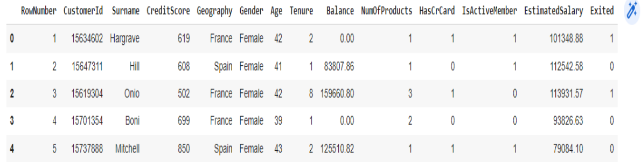 df['HasCrCard'] **=** df['HasCrCard']**.**astype('category')

df['IsActiveMember'] **=** df['IsActiveMember']**.**astype('category')

df['Exited'] **=** df['Exited']**.**astype('category')

df **=** df**.**drop(columns**=**['RowNumber', 'CustomerId', 'Surname'])

df**.**head()

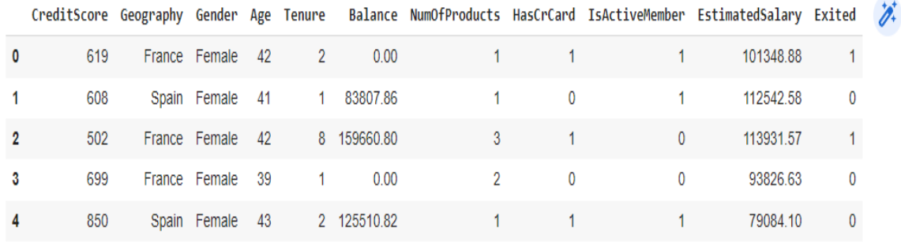

**Task-3:**

**3. Perform Below Visualizations.**

● Univariate Analysis

● Bi - Variate Analysis

● Multi - Variate Analysis

**Solution:**

import seaborn as sn

density = df['Exited'].value_counts(normalize=True).reset_index()

sn.barplot(data=density, x='index', y='Exited', );

density

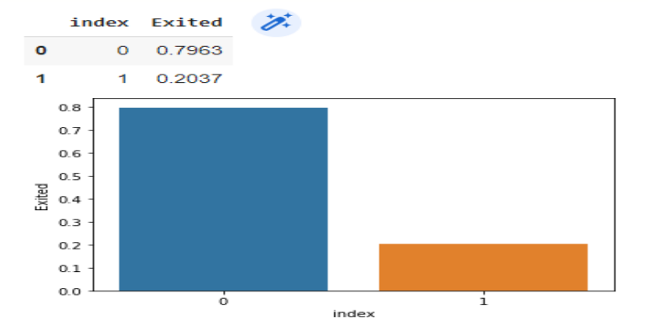

import matplotlib.pyplot as plt

categorical = df.drop(columns=['CreditScore', 'Age', 'Tenure', 'Balance', 'EstimatedSalary'])

rows = int(np.ceil(categorical.shape[1] / 2)) - 1

# create sub-plots anf title them

fig, axes = plt.subplots(nrows=rows, ncols=2, figsize=(10,6))

axes = axes.flatten()

for row in range(rows):

cols = min(2, categorical.shape[1] - row*2)

for col in range(cols):

col_name = categorical.columns[2 * row + col]

ax = axes[row*2 + col]

sn.countplot(data=categorical, x=col_name, hue="Exited", ax=ax);

plt.tight_layout()

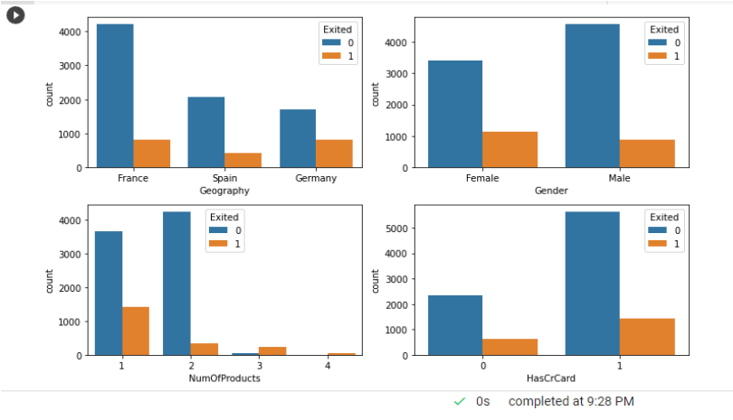

**Task-4:**

**Perform descriptive statistics on the dataset**

df.info()

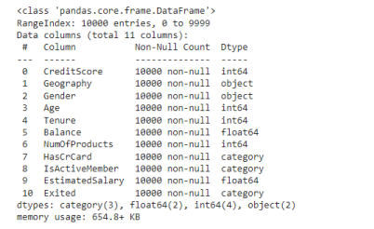

df.describe()

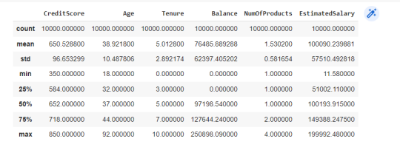

**Task-5:**

**Handle the Missing values.**

**Solution:**

df.isna().sum()

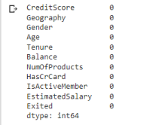

for i in df:

if df[i].dtype=='object' or df[i].dtype=='category':

print("unique of "+i+" is "+str(len(set(df[i])))+" they are "+str(set(df[i])))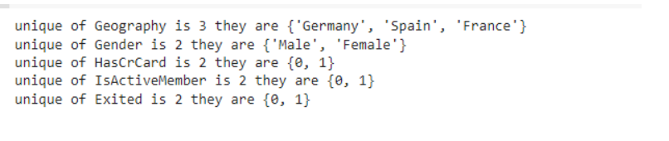

**Task-6:**

**Find the outliers and replace the outliers**

**Solution:**

finding whether the outlier is present

def box_scatter(data, x, y):

fig, (ax1, ax2) = plt.subplots(nrows=2, ncols=1, figsize=(16,6))

sn.boxplot(data=data, x=x, ax=ax1)

sn.scatterplot(data=data, x=x,y=y,ax=ax2)

box_scatter(df,'CreditScore','Exited');

plt.tight_layout()

print(f"# of Bivariate Outliers: {len(df.loc[df['CreditScore'] < 400])}")

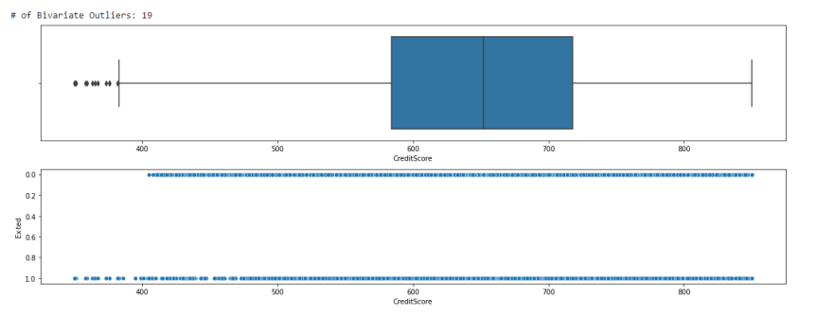 box_scatter(df,'Age','Exited');

plt.tight_layout()

print(f"# of Bivariate Outliers: {len(df.loc[df['Age'] > 87])}")

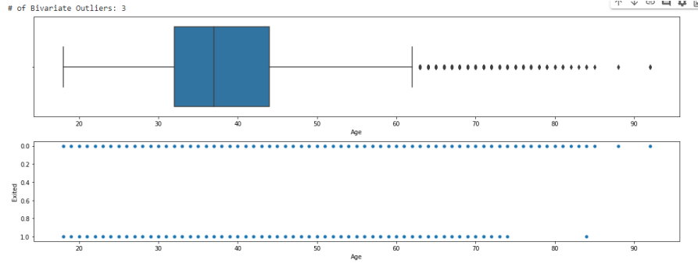

box_scatter(df,'Balance','Exited');

plt.tight_layout()

print(f"# of Bivariate Outliers: {len(df.loc[df['Balance'] > 220000])}")

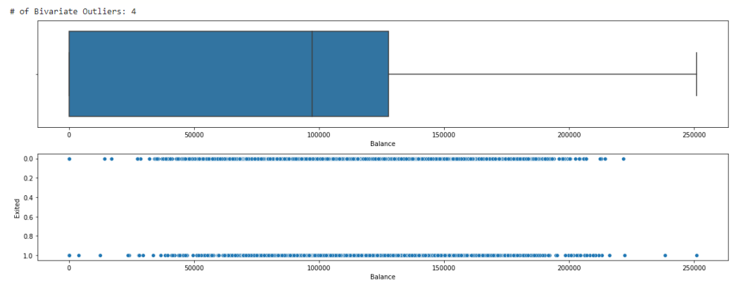

9

box_scatter(df,'EstimatedSalary','Exited');

plt.tight_layout()

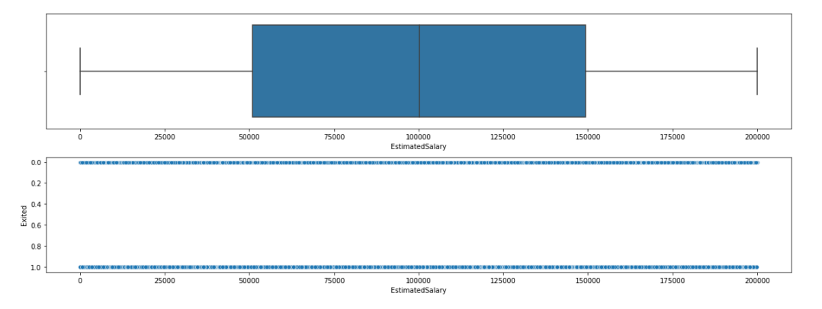

**Removing of Outliers**

for i in df:

if df[i].dtype=='int64' or df[i].dtypes=='float64':

q1=df[i].quantile(0.25)

q3=df[i].quantile(0.75)

iqr=q3-q1

upper=q3+1.5*iqr

lower=q1-1.5*iqr

df[i]=np.where(df[i] >upper, upper, df[i])

df[i]=np.where(df[i] <lower, lower, df[i])

After removing the outliers the boxplot will be like

box_scatter(df,'CreditScore','Exited');

plt.tight_layout()

print(f"# of Bivariate Outliers: {len(df.loc[df['CreditScore'] < 400])}")

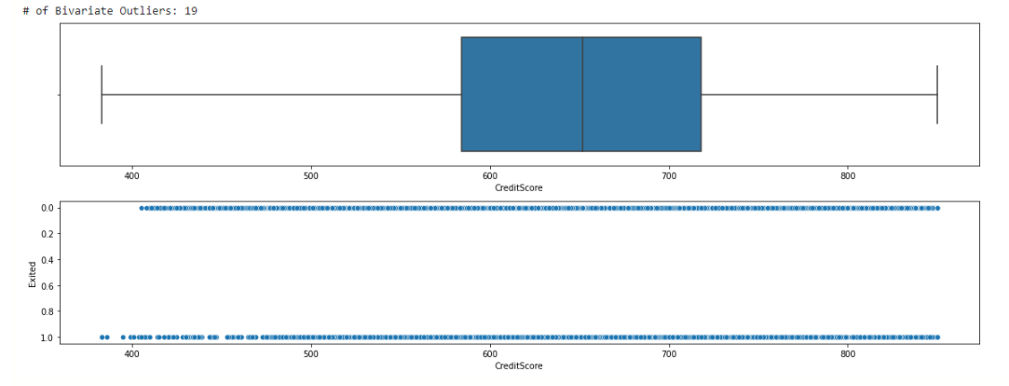

box_scatter(df,'Age','Exited');

plt.tight_layout()

print(f"# of Bivariate Outliers: {len(df.loc[df['Age'] > 87])}")

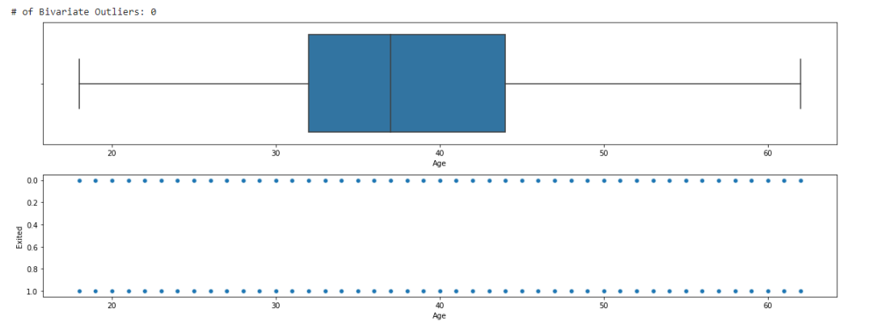

box_scatter(df,'Balance','Exited');

plt.tight_layout()

print(f"# of Bivariate Outliers: {len(df.loc[df['Balance'] > 220000])}")

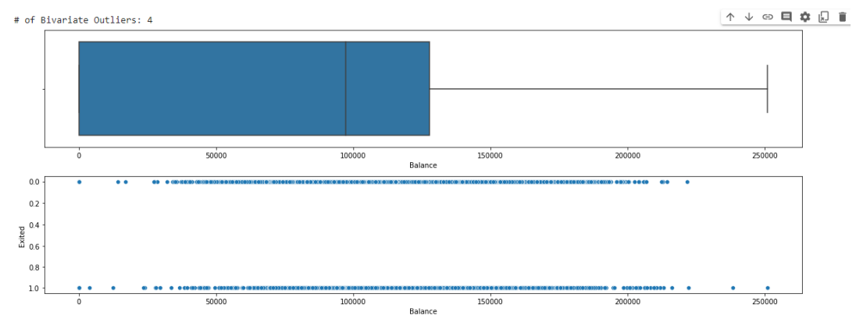

**TASK-7**

**Check for Categorical columns and perform encoding. Solution:**

**from** sklearn.preprocessing **import** LabelEncoder

encoder**=**LabelEncoder()

**for** i **in** df:

**if** df[i]**.**dtype**==**'object' **or** df[i]**.**dtype**==**'category':

df[i]**=**encoder**.**fit_transform(df[i])

**TASK-8**

**Split the data into dependent and independent variables.** Solution:

x**=**df**.**iloc[:,:**-**1]

x**.**head()

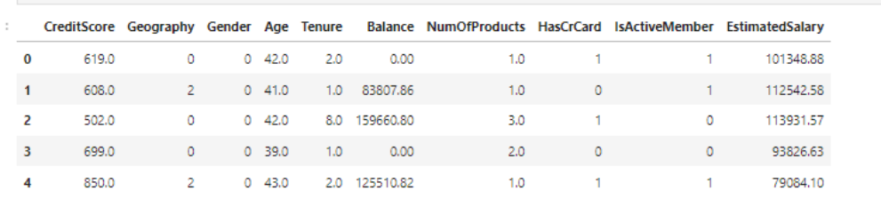

y**=**df**.**iloc[:,**-**1]

y**.**head()

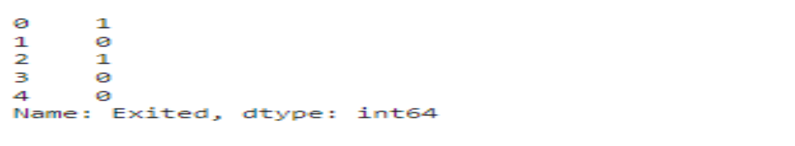

**TASK-9:**

**Scale the independent variables**

**Solution:**

**from** sklearn.preprocessing **import** StandardScaler

scaler**=**StandardScaler()

x**=**scaler**.**fit_transform(x)

x

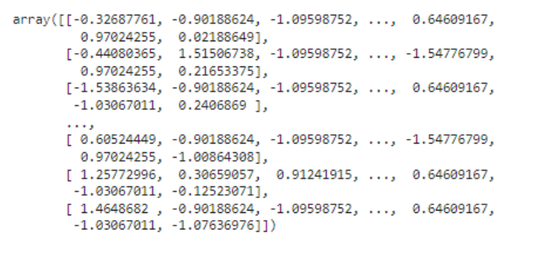

**TASK-10:**

**Split the data into training and testing**

**Solution:**

**from** sklearn.model_selection **import** train_test_split

x_train,x_test,y_train,y_test**=**train_test_split(x,y,test_size**=**0.33)

